- Amount of Access Given to Users

- VPN setups normally have a very troublesome time to keep the users of the VPN in check after they have successfully logged into the system. They are older, that is why they are simply not built to support customised access rules for every single employee, which leads to a scenario where they are either entirely denied access, or are granted complete and total access. There is no essetnial midground. After a user has authenticated themselves, they are granted full access to the entire corporate network, which creates a huge, unnecessary security gap in the system. If an attacker manages to gain employee login credentials, they have essentially unlimited access to roam through the company’s internal networks and access sensitive areas without anybody even noticing. Normal VPNs have the drawback of allowing exactly this kind of lateral movement.

- ZTNA is the modenr equivalent alternative of the old VPN system. It operates by adopting a very strict need-to-know basis. Where VPN just hands over the entire access to the whole network, this approach makes a very strong least privilege rule. Admin users can create and assign higly customised, and specific, granular rules, tailor made to individual users and their respective role. An employee is only allowed to see and interact with the exact applications that are important for their job, while the rest of the company’s infra and architecture remains completely hidden, and physically inaccessible to them.

- How Private Data is Routed and Handled

- Old VPNs mostly rely on big, clunky physical hardware appliances sitting in a server room. These hardware based systems are very hard and difficult to maintain, upgrade and scale up when demand suddenly increases. What is worse, is that many of these older setups act as a middleman for data, which is a not very trustworthy process. When remote employees connect htrought the VPN, their daily work and private data is very often routed directly through the vendor’s own machines so that ht etraffic can be checked and inspected. This makes it a huge privacy flaw and leaves the company open to supply chain attacks, where if the vendor is attacked, then the users’ sensitive data is at risk.

- The ZTNA equivalent of VPNs removes the middleman part of the deal entirely. It is deployed completely in the cloud, making it cost-effective, cheap, easily scalable, and deployable in a very short time. Importantly, they separate the checking from the actual transfer of data. The system will verify the user’s identity, but the user’s actual data flows directly to the destination without actually passing through the vendor’s servers.

- Tracking and Monitoring Network Activity

- In the case of VPNs, since they are older technology, the IT and security teams are actually really blind, in the sense that these old setups are notorious for lacking strong monitoring features and simply fail to produce detailed activity reports or logs that many businesses rely on. Also, because of the little to no logging of everyday network traffic, it is very difficult to single out and spot suspicious behaviour, or even troubleshot connection issues, or actually even figure out what actually hapened after a security breach takes place.

- The ZTNA alternative means getting a continuous and total view of the entire environment. It automatically tracks and logs all network traffic in the background. This all around visibility is very good because it makes passing the strict security audits and compliance checks very easy. The system also joins and integrates easily with modern reporting tools, making sure that admins always know exactly who is connecting at any given moment, and exactl what they are accessing, and what they are allowed to access.

VPN Flow

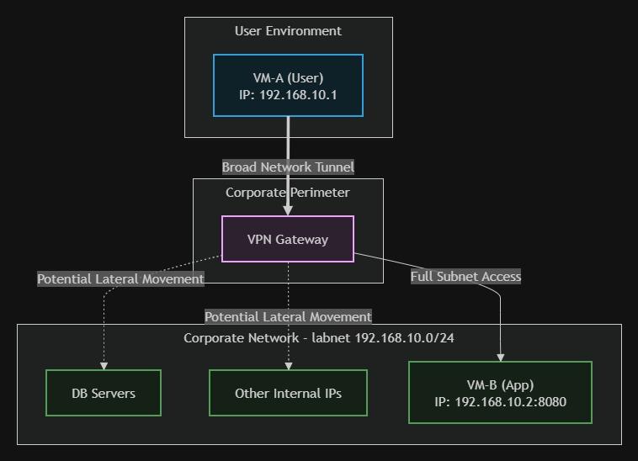

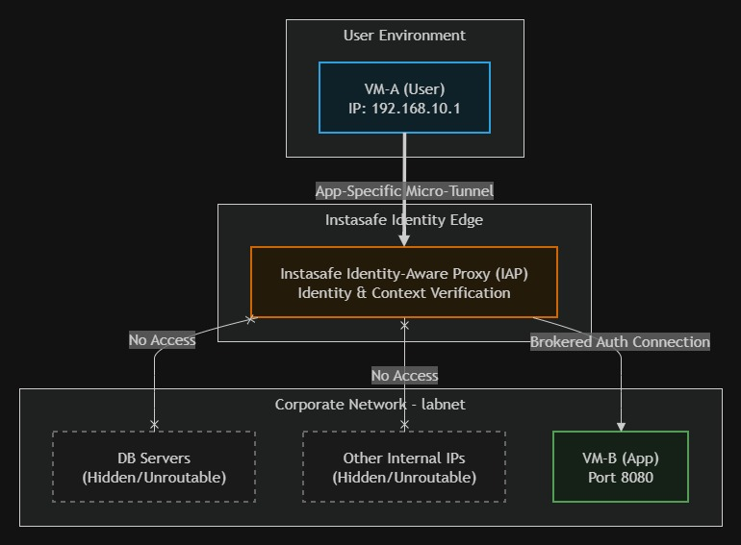
ZTNA Flow

